1. Find out all the domestic customers.

select * from customer where customer_type = 'domestic';

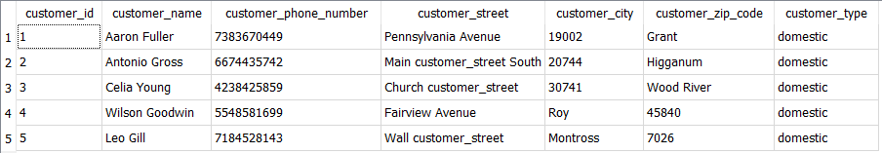

2. Find all the employee ID, name and hired date who were hired before the end of May 2015.

select employee_id employee_name, employee_date_hired from employee where employee_date_hired <= '2015-05-30' order by employee_id DESC;

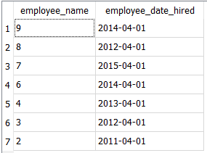

3. Find out the employee id, name who has more than 2 skills.

SELECT employee.employee_id, employee_name, count(employee_skill.employee_id) FROM employee, employee_skill where employee_skill.employee_id = employee.employee_id GROUP BY employee.employee_id HAVING count(employee_skill.employee_id)>2;

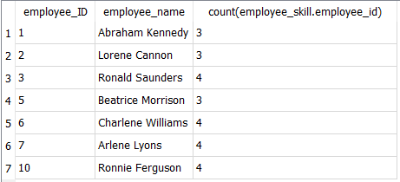

4. Find out all the Japanese customers

Select * FROM international_customer where international_customer_country = 'Japan';



5. Find out the customerid, customer name, customer type and how many orders each customer has.

SELECT customer.customer_id, customer_name, customer_type, count(orders.customer_id) as ordernumber

FROM customer

LEFT JOIN orders

ON customer.customer_id = orders.customer_id

group by customer.customer_id;

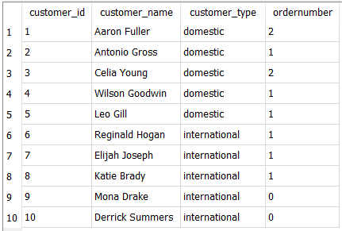

6.Find out the vehicle id, make, model, year, and cost of the vehicles which the costs are above average.

SELECT vehicle_id, vehicle_make, vehicle_model, vehicle_year, vehicle_cost

FROM vehicle

WHERE vehicle_cost > (SELECT AVG (vehicle_cost) FROM vehicle);

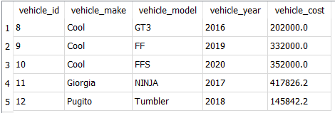

7.Find out vehicle make, model which were made after 2015, and all the service info from the vehicle and service table.

SELECT vehicle.vehicle_make, vehicle.vehicle_model, vehicle.vehicle_year, service.*

FROM vehicle

INNER JOIN service ON vehicle.vehicle_id = service.vehicle_id

WHERE vehicle_year > '2015'

ORDER BY service.vehicle_id;

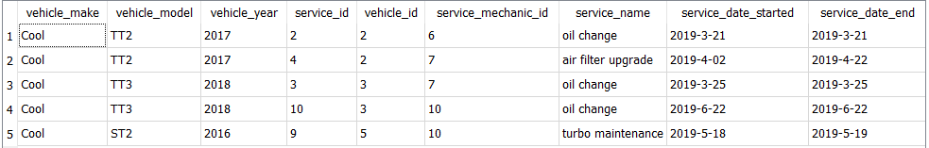

8. Find out the mechanic id of the emchanic whose houly rate higher than 40 and who works with the parts lower than 3000, and the name of the parts.

SELECT employee_id, mechanic_hourly_rate, part_name, part_price

FROM mechanic

LEFT JOIN part ON employee_id = mechanic_id

WHERE mechanic_hourly_rate>40 AND employee_id = (SELECT mechanic_id from part where part_price<3000)

order by employee_id;

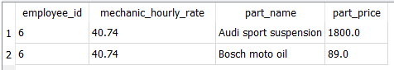

9.Find out the sales person's average rate of commission of total vehicle cost

SELECT AVG(sales_person_commission) / AVG(vehicle_cost)

FROM sales_person, vehicle;



1. Find out the info of the supplier who offers the most expensive part

SELECT DISTINCT*, MAX(part_price) FROM supplier, part

WHERE supplier.supplier_id= part.supplier_id;

